**VETRI IT SYSTEMS PRIVATE LIMITED**

**PROJECT REPORT**

**PROJECT TITLE: VETRI ELECTRONICS**

**1. Project Overview**

**Project Name:** Fitnes website  
**Project Assigned Date:** 00-00-2025  
**Planned Completion Date:** 00-00-2025  
**Delivery Date:** 00-00-2025

**2. Project Team**

* **Project Manager:** Ragavan M
* **Designer:** Malathy
* **Developer(s):** Ramya.T.K
* **Testing Team:** Yoga Varshini

**3. Technology Stack**

* **Frontend Technologies:** HTML, CSS

**4. Project Scope**

The Vetri Electronic project aims to develop a comprehensive eCommerce platform that allows users to browse and purchase Handmade craft Items seamlessly. The system will provide an intuitive user interface, secure payment processing, and an efficient order management system for administrators.

**Key Objectives:**

* Develop a user-friendly and responsive website for Vetri E-Commerce.
* Implement a robust authentication and authorization system.
* Ensure a secure and reliable payment gateway.
* Enable real-time order tracking and inventory management.
* Provide detailed sales reports and analytics.
* Deploy the platform on a secure VPS with high availability.

**5. Project Modules**

* **User Authentication & Management**
* **Product Catalog & Listing**
* **Order Management System**
* **Reports & Data Analysis**
* **Cart Details**
* **About Company & Contact Details**
* **Payment Details**
* **Login new user & old user**

**6. Project Code**

**Frontend Code (HTML Code) :**

**Index.html**

**7. Output & Screenshots(Add your website screenshots here)**

**Code: https://github.com/ramya23071996/pro1/commit/ecb0998366916cc4c76bd82e67393d660c6c3e4b**

**Output: https://ramya23071996.github.io/pro1/Prototype/2-Handmade_Craftstore/**

* **Homepage:** Displays Handmade craft Website.

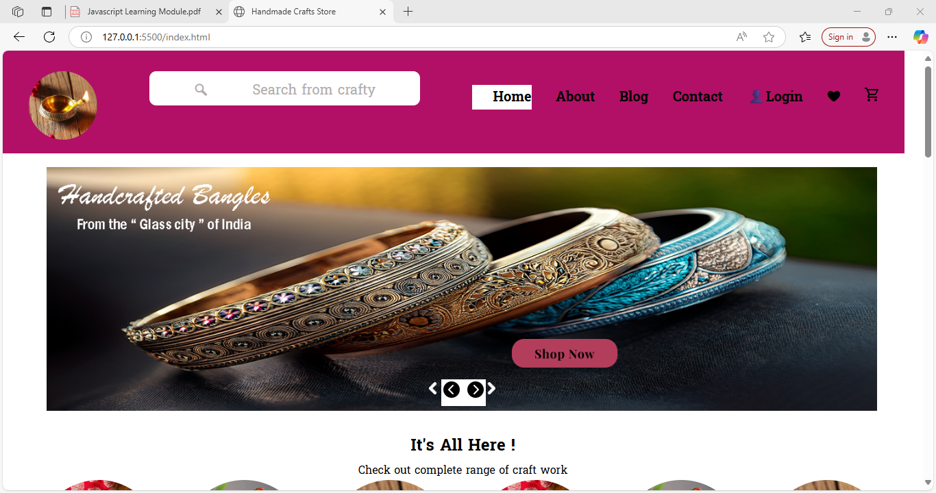

* **Product Page:** Displays featured handmadecraft products
* 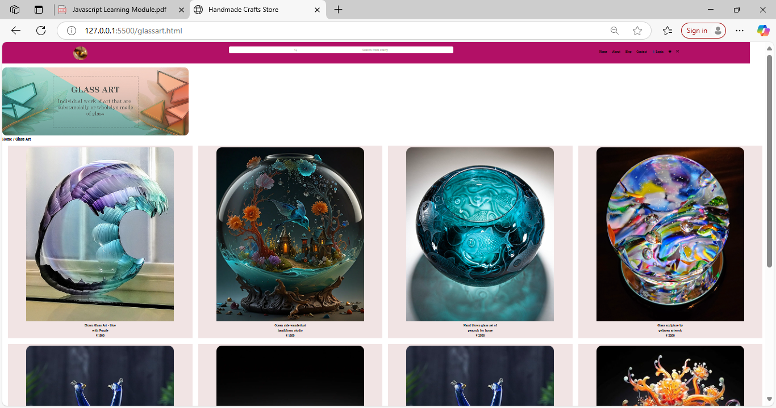.
* **About Company Page:** Shows detailed descriptions.

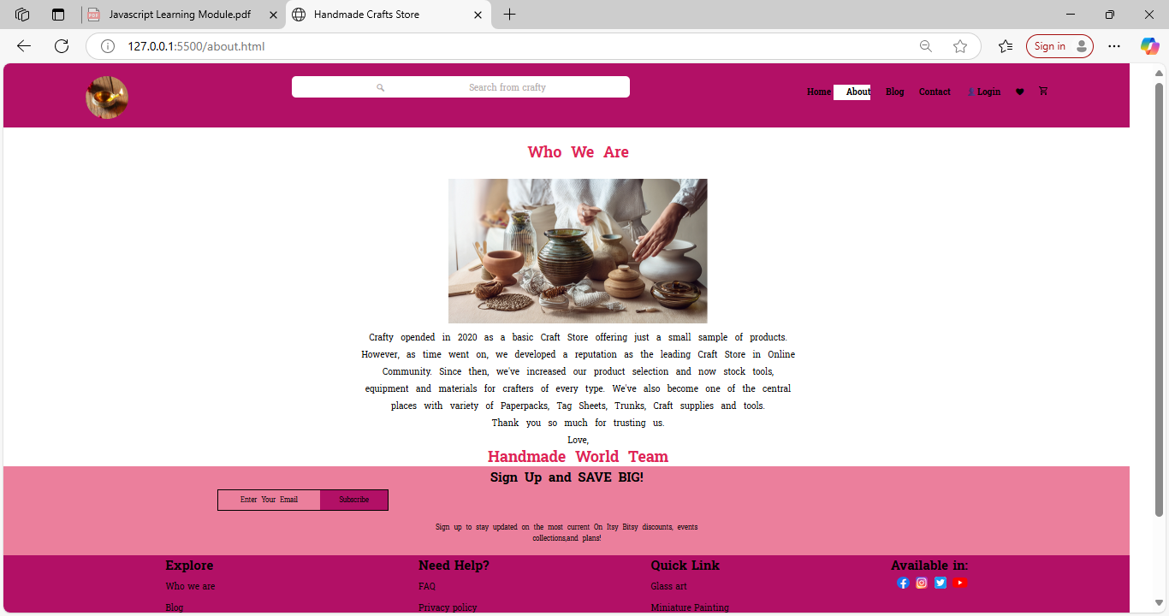

* **Cart & Checkout:** Users can add items and proceed with secure payments.
* 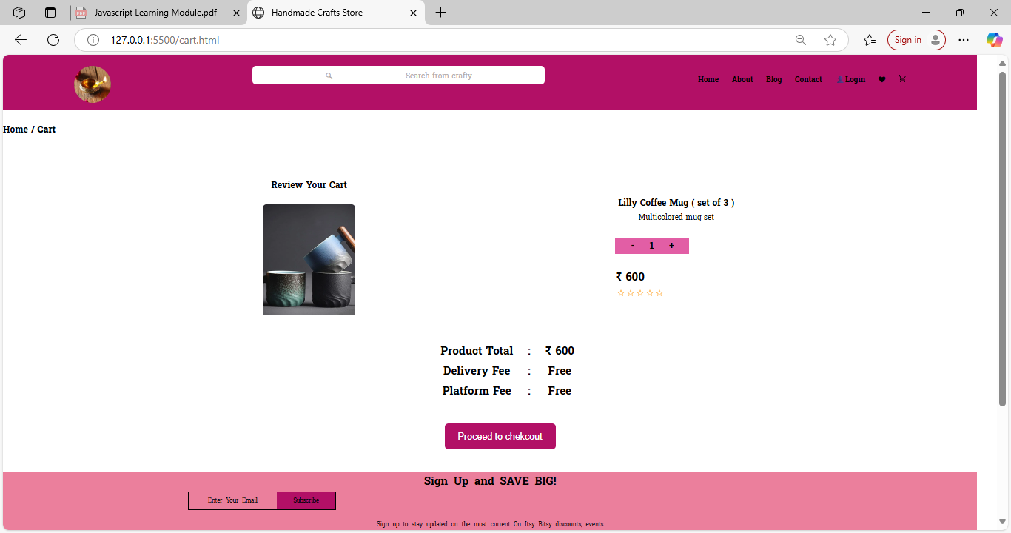

**8. Conclusion**

The Vetri E-Commerce project aims to deliver a robust and scalable eCommerce platform leveraging variety of Handmade craft Items. The successful implementation of this project will provide an efficient and seamless experience for users and administrators. The platform will ensure secure transactions, efficient order processing, and insightful analytics for business growth.

**Prepared By: Ramya T.K  
Date: 05-05-2025  
Reviewed By: Ragavan M  
Approved By: Ragavan M**